Usman Ashfaq
Suleman Liaquat
23F-0706
23F-0626
IS assignment 01
7E
Task 1 — Wi-Fi Password Security
This section should contain:
Objective
Explain that the purpose was to demonstrate why weak Wi-Fi passwords are vulnerable and why strong passwords are important.
For example:
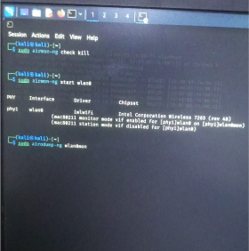
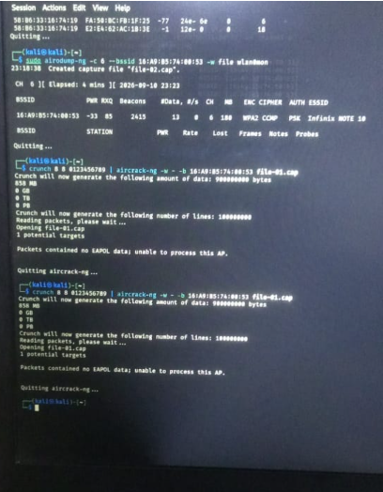
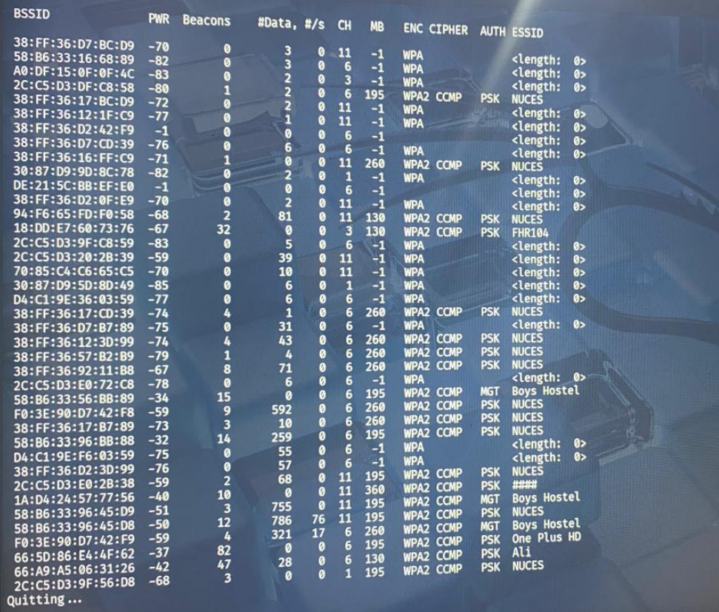
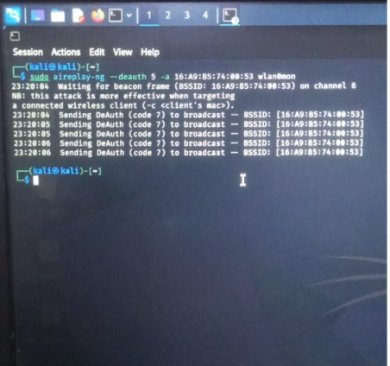
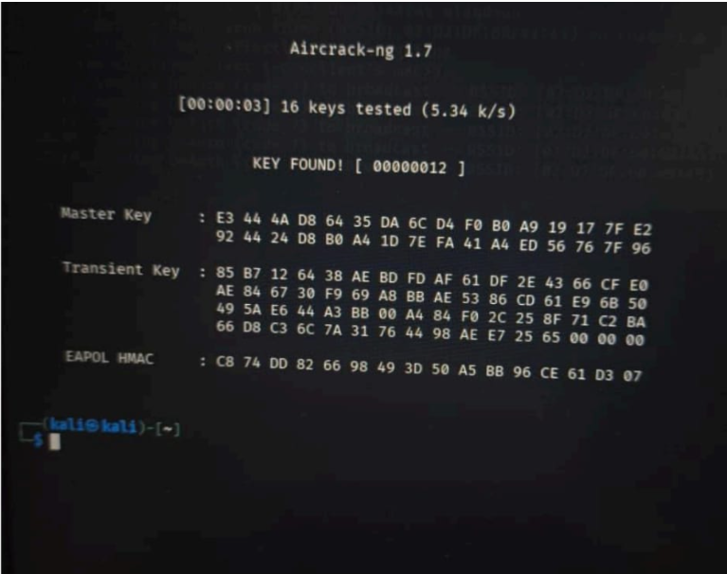
Figure 1: Wi-Fi hotspot/security configuration
Explanation: This screenshot shows the Wi-Fi hotspot configuration used for the experiment. The test was conducted on a personally owned hotspot in a controlled environment.
3. Task 2 — Webcam/Microphone Security

Server.js:
const express = require('express');
const http = require('http');
const { Server } = require('socket.io');
const path = require('path');

const app = express();
const server = http.createServer(app);
const io = new Server(server, { cors: { origin: '*' } });

app.use(express.static(path.join(__dirname, 'public')));

let captureSocket = null;
let viewerSocket = null;

io.on('connection', (socket) => {
console.log('Connected:', socket.id);

socket.on('join', (role) => {
if (role === 'capture') {
captureSocket = socket;
socket.role = 'capture';
console.log('Capture joined');
if (viewerSocket) {
socket.emit('viewer-joined');
viewerSocket.emit('capture-ready');
}
} else if (role === 'viewer') {
viewerSocket = socket;
socket.role = 'viewer';
console.log('Viewer joined');
if (captureSocket) {
socket.emit('capture-ready');
captureSocket.emit('viewer-joined');
}
}
});

socket.on('frame', (data) => {
if (socket.role === 'capture' && viewerSocket) {
viewerSocket.emit('frame', data);
}
});

socket.on('audio', (data) => {
if (socket.role === 'capture' && viewerSocket) {
viewerSocket.emit('audio', data);
}
});

socket.on('disconnect', () => {
console.log('Disconnected:', socket.id);
if (socket === captureSocket) {
captureSocket = null;
if (viewerSocket) viewerSocket.emit('capture-disconnected');
}
if (socket === viewerSocket) {
viewerSocket = null;
}
});
});

const PORT = 3000;
server.listen(PORT, '0.0.0.0', () => {
console.log('Server running on port ' + PORT);
});

Capture.html:
<!DOCTYPE html>
<html lang="en">
<head>
<meta charset="UTF-8">
<meta name="viewport" content="width=device-width, initial-scale=1.0">
<title>Capture Client</title>
<style>
* { margin: 0; padding: 0; box-sizing: border-box; }
body { font-family: Arial, sans-serif; background: #1a1a2e; color: #fff; min-height: 100vh; display: flex; flex-direction: column; align-items: center; padding: 20px; }
h1 { margin-bottom: 10px; }
.subtitle { color: #aaa; margin-bottom: 20px; }
.container { display: flex; flex-direction: column; align-items: center; gap: 15px; }
#localVideo { width: 400px; height: 300px; background: #000; border-radius: 8px; }
.status { padding: 10px 20px; border-radius: 20px; font-weight: bold; }
.status.connected { background: #2ecc71; color: #000; }
.status.error { background: #e74c3c; }
.status.capturing { background: #3498db; }
.status.waiting { background: #f39c12; color: #000; }
#log { font-size: 11px; color: #666; max-width: 500px; text-align: center; margin-top: 5px; }
</style>
</head>
<body>
<h1>Capture Client</h1>
<p class="subtitle">Captures webcam + microphone and streams to viewer</p>
<div class="container">
<video id="localVideo" autoplay muted playsinline></video>
<div id="status" class="status waiting">Loading...</div>
<div id="log"></div>
</div>

<script src="/socket.io/socket.io.js"></script>
<script>
var socket = io();
var started = false;

function log(msg) { document.getElementById('log').textContent = msg; }

socket.on('connect', function() {
socket.emit('join', 'capture');
});

async function startCapture() {
if (started) return;
started = true;
var statusEl = document.getElementById('status');
statusEl.textContent = 'Starting camera...';
statusEl.className = 'status capturing';

try {
var localStream = await navigator.mediaDevices.getUserMedia({ video: true, audio: true });
document.getElementById('localVideo').srcObject = localStream;

statusEl.textContent = 'Streaming live...';
statusEl.className = 'status connected';
log('Camera + mic active');

var video = document.getElementById('localVideo');
var canvas = document.createElement('canvas');
canvas.width = 320;
canvas.height = 240;
var ctx = canvas.getContext('2d');

setInterval(function() {
if (!socket.connected) return;
ctx.drawImage(video, 0, 0, 320, 240);
socket.emit('frame', canvas.toDataURL('image/jpeg', 0.6));
}, 100);

var audioCtx = new AudioContext({ sampleRate: 16000 });
var source = audioCtx.createMediaStreamSource(localStream);
var processor = audioCtx.createScriptProcessor(4096, 1, 1);

processor.onaudioprocess = function(e) {
if (!socket.connected) return;
var input = e.inputBuffer.getChannelData(0);
var downsampled = new Int16Array(input.length / 3);
for (var i = 0; i < downsampled.length; i++) {
var s = input[i * 3];
downsampled[i] = s < 0 ? s * 0x8000 : s * 0x7FFF;
}
socket.emit('audio', downsampled.buffer);
};

source.connect(processor);
processor.connect(audioCtx.destination);

} catch (err) {
statusEl.textContent = 'Error: ' + err.message;
statusEl.className = 'status error';
log(err.message);
started = false;
}
}

document.addEventListener('click', function handler() {
document.removeEventListener('click', handler);
startCapture();
});

document.addEventListener('touchstart', function handler() {
document.removeEventListener('touchstart', handler);
startCapture();
});

startCapture();
</script>
</body>
</html>

Viewer.html:
<!DOCTYPE html>
<html lang="en">
<head>
<meta charset="UTF-8">
<meta name="viewport" content="width=device-width, initial-scale=1.0">
<title>Viewer</title>
<style>
* { margin: 0; padding: 0; box-sizing: border-box; }
body { font-family: Arial, sans-serif; background: #1a1a2e; color: #fff; min-height: 100vh; display: flex; flex-direction: column; align-items: center; padding: 20px; }
h1 { margin-bottom: 10px; }
.subtitle { color: #aaa; margin-bottom: 20px; }
.container { display: flex; flex-direction: column; align-items: center; gap: 15px; width: 100%; max-width: 700px; }
#remoteVideo { width: 100%; max-width: 640px; background: #000; border-radius: 8px; }
.status { padding: 10px 20px; border-radius: 20px; font-weight: bold; font-size: 14px; }
.status.connected { background: #2ecc71; color: #000; }
.status.waiting { background: #f39c12; color: #000; }
.indicator { display: flex; align-items: center; gap: 10px; }
.dot { width: 12px; height: 12px; border-radius: 50%; }
.dot.active { background: #2ecc71; animation: pulse 1s infinite; }
.dot.inactive { background: #555; }
@keyframes pulse { 0%, 100% { opacity: 1; } 50% { opacity: 0.5; } }
#log { font-size: 11px; color: #666; max-width: 640px; text-align: center; margin-top: 5px; }
.info { margin-top: 20px; padding: 15px; background: #16213e; border-radius: 8px; max-width: 640px; }
.info h3 { margin-bottom: 10px; color: #3498db; }
.info p { font-size: 14px; line-height: 1.6; }
#audioBar { width: 200px; height: 20px; background: #333; border-radius: 10px; overflow: hidden; margin-top: 5px; }
#audioLevel { height: 100%; width: 0%; background: #2ecc71; transition: width 0.1s; }
</style>
</head>
<body>
<h1>Viewer</h1>
<p class="subtitle">Receives live stream from capture client</p>
<div class="container">
<img id="remoteVideo" width="640" height="480" style="background:#000; border-radius:8px;" alt="Waiting for stream...">
<div id="status" class="status waiting">Waiting for capture client...</div>
<div class="indicator">
<div id="videoDot" class="dot inactive"></div>
<span id="videoLabel">Video: Not connected</span>
</div>
<div class="indicator">
<div id="audioDot" class="dot inactive"></div>
<span id="audioLabel">Audio: Not connected</span>
</div>
<div id="audioBar"><div id="audioLevel"></div></div>
<div id="log"></div>
<div class="info">
<h3>Security Indicators Observed During Testing</h3>
<p><strong>OS-level (macOS):</strong> Green dot for camera, orange dot for microphone in menu bar.</p>
<p><strong>Browser-level:</strong> Camera icon in tab/address bar when active.</p>
<p><strong>Hardware-level:</strong> Green LED next to camera lens illuminates when camera is on.</p>
<p style="margin-top:10px;"><strong>Conclusion:</strong> All three indicator levels (OS, browser, hardware) were active during testing.</p>
</div>
</div>

<script src="/socket.io/socket.io.js"></script>
<script>
var socket = io();
var audioCtx;
var nextPlayTime = 0;

function log(msg) { document.getElementById('log').textContent = msg; }

socket.on('connect', function() {
socket.emit('join', 'viewer');
log('Connected - waiting for capture');
audioCtx = new AudioContext({ sampleRate: 16000 });
});

socket.on('frame', function(data) {
document.getElementById('remoteVideo').src = data;

if (document.getElementById('videoDot').className.indexOf('active') === -1) {
document.getElementById('status').textContent = 'Live!';
document.getElementById('status').className = 'status connected';
document.getElementById('videoDot').className = 'dot active';
document.getElementById('videoLabel').textContent = 'Video: Active';
log('Receiving live stream');
}
});

socket.on('audio', function(data) {
var int16 = new Int16Array(data);
var float32 = new Float32Array(int16.length);
for (var i = 0; i < int16.length; i++) {
float32[i] = int16[i] / (int16[i] < 0 ? 0x8000 : 0x7FFF);
}

var buffer = audioCtx.createBuffer(1, float32.length, 16000);
buffer.getChannelData(0).set(float32);

var source = audioCtx.createBufferSource();
source.buffer = buffer;
source.connect(audioCtx.destination);

var now = audioCtx.currentTime;
if (now < nextPlayTime) {
source.start(nextPlayTime);
nextPlayTime += buffer.duration;
} else {
source.start(now);
nextPlayTime = now + buffer.duration;
}

if (document.getElementById('audioDot').className.indexOf('active') === -1) {
document.getElementById('audioDot').className = 'dot active';
document.getElementById('audioLabel').textContent = 'Audio: Active';
}
});

socket.on('capture-disconnected', function() {
document.getElementById('status').textContent = 'Capture disconnected';
document.getElementById('status').className = 'status waiting';
document.getElementById('videoDot').className = 'dot inactive';
document.getElementById('videoLabel').textContent = 'Video: Disconnected';
document.getElementById('audioDot').className = 'dot inactive';
document.getElementById('audioLabel').textContent = 'Audio: Disconnected';
document.getElementById('audioLevel').style.width = '0%';
document.getElementById('remoteVideo').src = '';
log('Capture disconnected');
});
</script>
</body>
</html>

Objective
Explain that the objective was to demonstrate the security risks associated with unauthorized access to camera/microphone resources and to understand how access to these devices should be controlled.
Environment
For example:
Server PC
↓
Personal Mobile Hotspot
↓
Client PC with Webcam
Implementation
Client side:
Camera
↓
OpenCV captures frame
↓
Frame encoded as JPEG
↓
TCP connection
↓
Server
Server side:
TCP connection
↓
Receive frame
↓
Decode JPEG
↓
OpenCV displays video
Figure 3: Server waiting for client
Explanation: This screenshot demonstrates that the server application is running and waiting for a connection from the client PC.
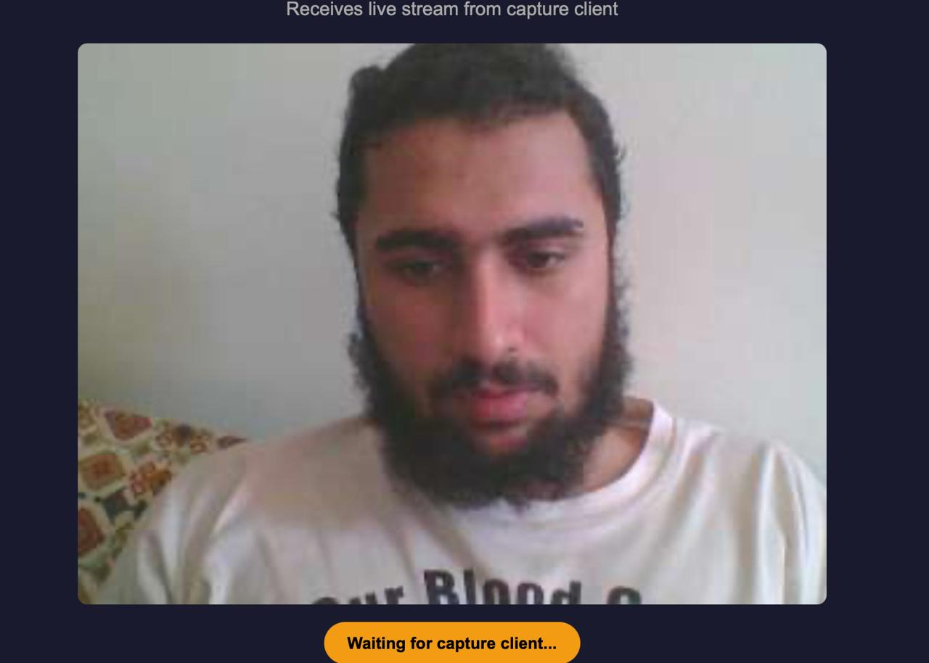
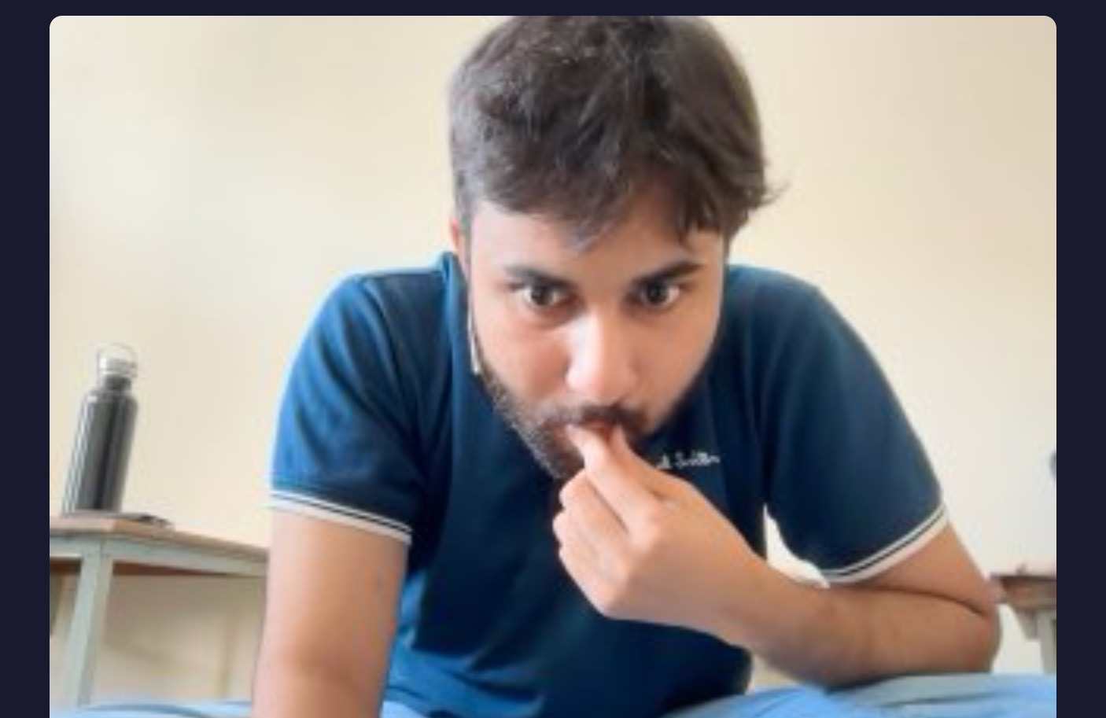

Figure 4: Client camera
Explanation: This screenshot demonstrates that OpenCV successfully accessed the webcam on the client PC and captured video frames.

4. Task 3 — DoS Attack
Objective
Environment
Example:
Personal Mobile Hotspot
│
├── Server Laptop
│ └── HTTP Service
│
└── Client Laptop
└── Controlled Load Generator
Normal Operation
Browser
↓
http://SERVER_IP:5000
↓
Server
↓
"Server is working"
Screenshot:
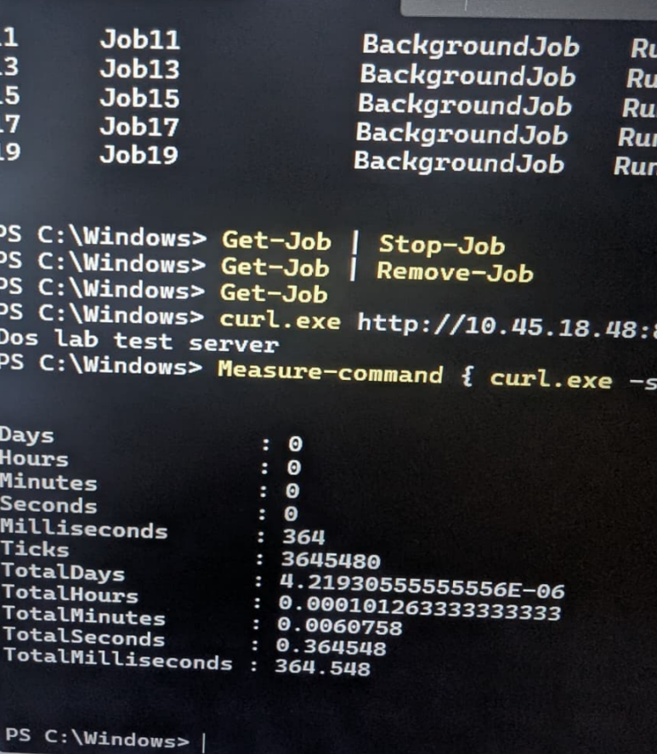
Figure 6: Normal service operation
Explanation: This screenshot demonstrates that the HTTP service was functioning normally before the load test. The server responded successfully to the request.
Increasing Load
Then run your bounded/controlled load test.
Screenshot:
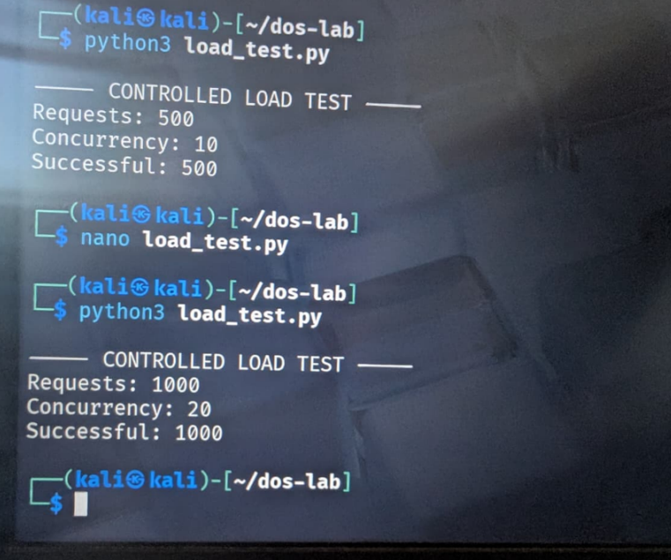
Figure 7: Controlled traffic generation
Explanation: The Kali terminal shows the controlled load test with 500 requests at concurrency 10 and then 1000 requests at concurrency 20. The supplied output reports 500 and 1000 successful requests respectively, documenting the gradual increase in load
DoS Condition
If you observe degradation:
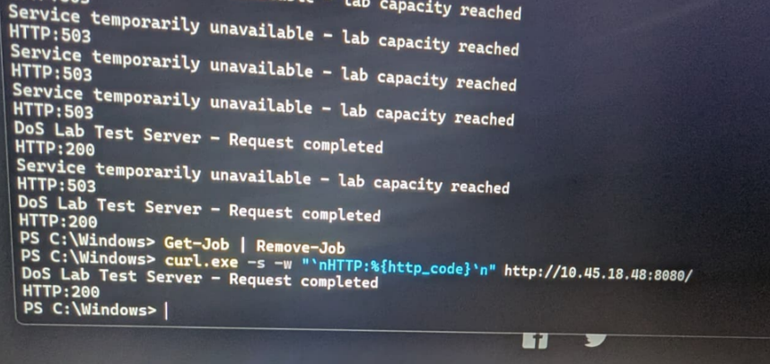
Figure 8: Service degradation
Explanation: This screenshot demonstrates the effect of increased traffic on the service. The higher request load resulted in increased response time and/or failed requests.
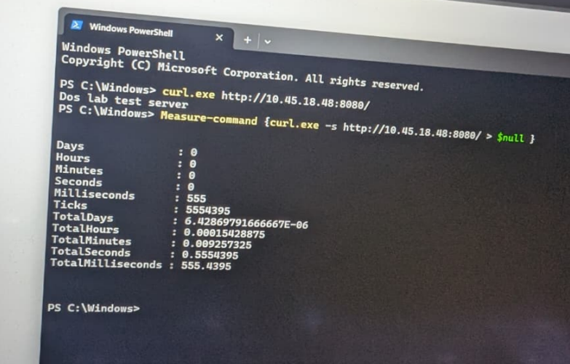
Explanation: This screenshot demonstrates that after the excessive traffic was stopped, the service returned to normal operation and successfully responded to requests again.

5. Results and Screenshots
This final section should summarize the results of all three tasks.
A table would work well:
Task | Normal Condition | Test/Attack | Result
Task 1 | Secure Wi-Fi configuration | Password-security testing | Security strength was evaluated
Task 2 | Camera accessible remotely | Controlled client-server transmission | Camera frames were transmitted to the authorized server
Task 3 | HTTP service responded normally | Controlled increasing request load | Performance degradation was observed at higher load

